CURRICULUM-VITAE

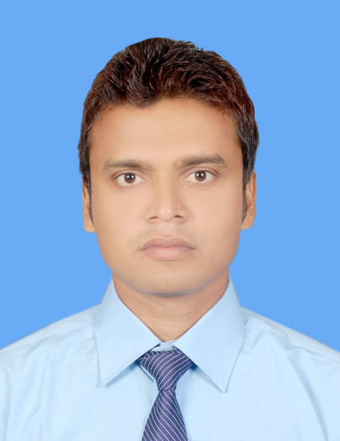
PERSONAL DETAILS

SHAILESH KUMAR MANJHI
Guardian’s Name : Ram Chandra Manjhi

Permanent Address:
Road No-13, House No- 405/D,
Girja Railway Colony Bargaon Gonda,
Uttar Pradesh, Pin Code- 271002

Present Address:
Bata Housing, Flat No- 4C9,
Batanagar Mallick Bazaar Kolkata,
West Bengal, Pin Code- 700140
Telephone Home: 09073389792
Personal Mobile: 08981218062
Email : manjhishailesh.rebel07@gmail.com
Date of Birth: 20/January/1990
Gender: Male
Nationality: Indian

CAREER OBJECTIVE

Intend to build a career with leading corporate, which will help me to explore myself fully and realize my potential, willing to work as a key player in challenging and creative environment, and also to expand skills and experience within the marketing department of a company

EDUCATION HISTORY

Specialization
Major – Marketing
Minor - Finance

Academic Qualifications
Degree | Institute/ University | Discipline | Year of Passing | % Aggregate
MBA | E.I.I.L.M. | Marketing / Finance | 2014 | 60.41%
Graduation | Lal Bhadur Shashtri Post Graduate Collage Gonda (U.P.)  Awadh University | B.Com | 2010 | 49.11%
Higher Secondary | P D L D I C Bankatashiv Bhatani Deoria (U.P.)  U.P. Board | Science | 2007 | 56.8%
Secondary | St. Xavier’s High School Gonda (U.P.)  CBSE Board | General | 2005 | 59.4%

WORK EXPERIENCE

July 2016 – current  April 2015-June 2016 | ICICI PRUDENTIAL LIC LTD.  Designation:  ASSOCIATE FINANCIAL SERVICE MANAGER  (BANKASSURANCE)  Primary Product:  INSURANCE PRODUCT-(ULIP,TERM)  HBL GLOBAL PVT. LTD.  Designation:  SALES EXECUTIVE (BANK CHANNEL)  Primary Product:  HOME LOANS

OTHER SKILLS AND CERTIFICATES

Computer Skills:
- Microsoft XP applications (Word, Excel, Office, PowerPoint, Outlook, Access)
- Microsoft Office Document Imaging and Scanning
- Acrobat Reader

Technical Skill:
- GITI (NCVT) in 2007 to 2009
- Trade-Fitter
- Apprentice-TATA MOTORS LIMITED
Duration-13-05-2010 to 12-05-2011

Other:
External Project
Project Title – A study of different factors which are creating an impact on the distribution channel of business dallies in north and central Kolkata.
- Organization – Business line, THE HINDU GROUP
- Duration – Two months

Language Skills:

- English
- Hindi
- Bengali

PERSONAL COMPETENCIES

- Ability to work in a fast-paced environment to set deadlines
- Excellent oral and written correspondence with an exceptional attention to detail
- Highly organised with a creative flair for project work
- Enthusiastic self-starter who contributes well to the team

INTERESTS AND ACTIVITIES

- Playing Cricket, Reading Book, Listening Music

DECLARATION:

I consider myself familiar with above mentioned aspects. I am also confident of my ability to work in a team. I hereby declare that the information furnished above is true to the best of my knowledge.

DATE:

PLACE: KOLKATA SIGNATURE OF THE STUDENT

